**Step 1:** Open the Task Scheduler as Administrator and Click on action Create Task.

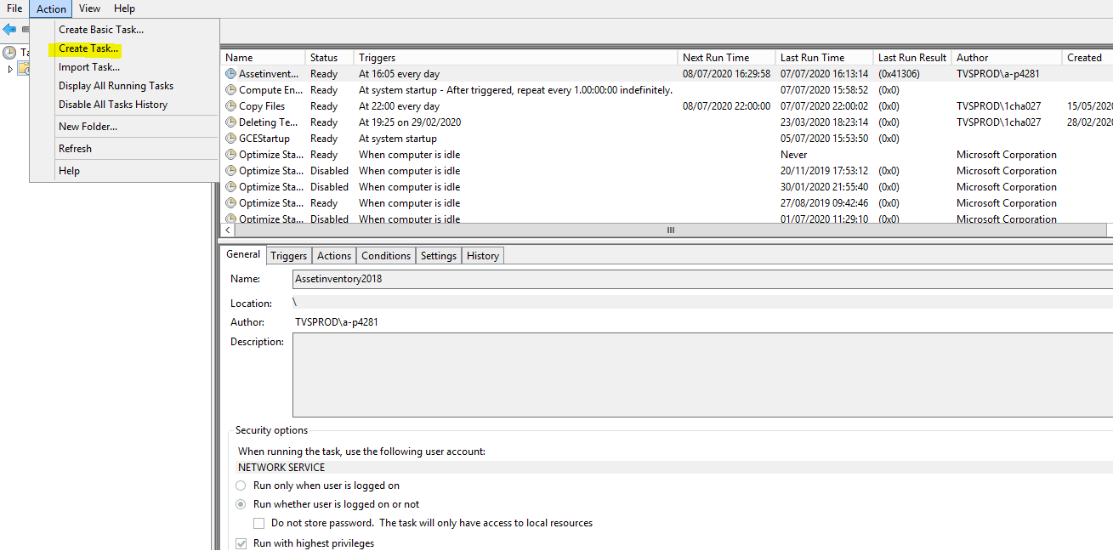

**Step 2:** After opening in General tab enable the below highlighted field and choose the OS Version of the remote system

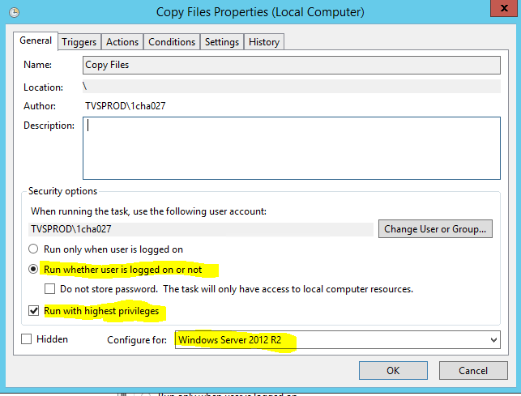

**Step 3: In trigger tab click on New and choose the time slot when the job must run. Refer sample in below image.**

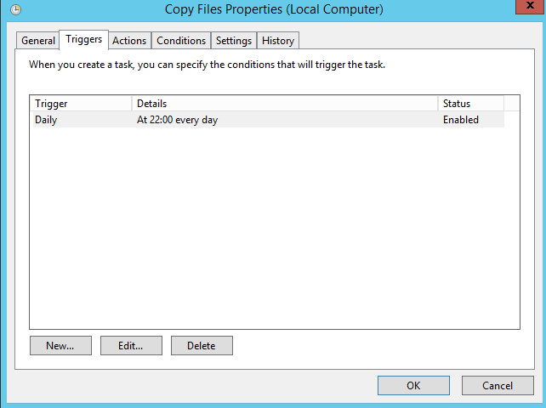

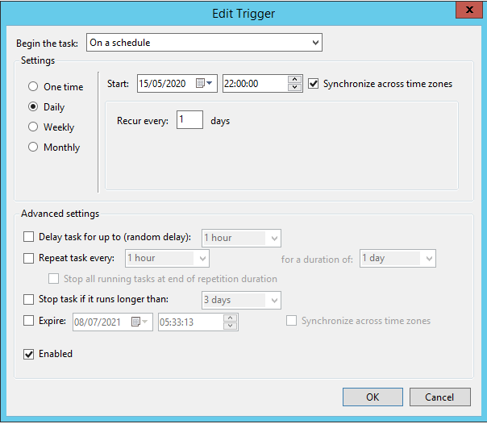

**Step 4:** In the actions tab click on the program script and paste the path where the PowerShell file is present and in add arguments path add **-file** “and script path where we have kept”

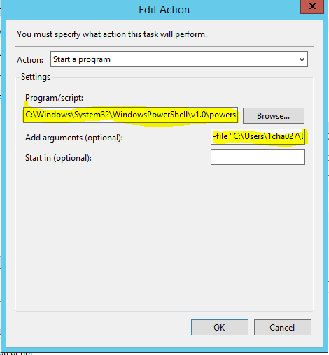

**Note:** Since this file uses PowerShell script, we are calling the PowerShell.exe to start in program script. Files use PowerShell to be executed.

**Reference Link:** <https://www.thewindowsclub.com/powershell-script-scheduled-task-0xfffd0000/>

**Step 5:** Enable the required conditions.

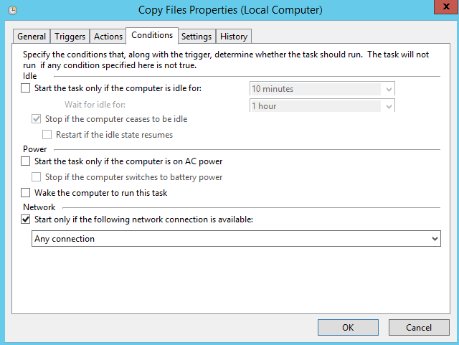

**Step 6:** In the setting tab enable the checkbox which we needed.

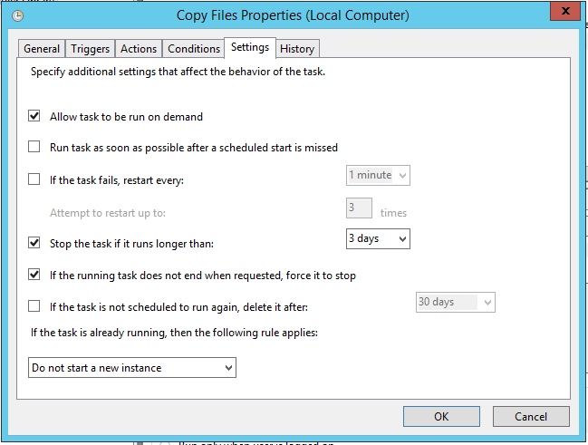

**Step 7:** Finally review all the settings and enable the task to perform.